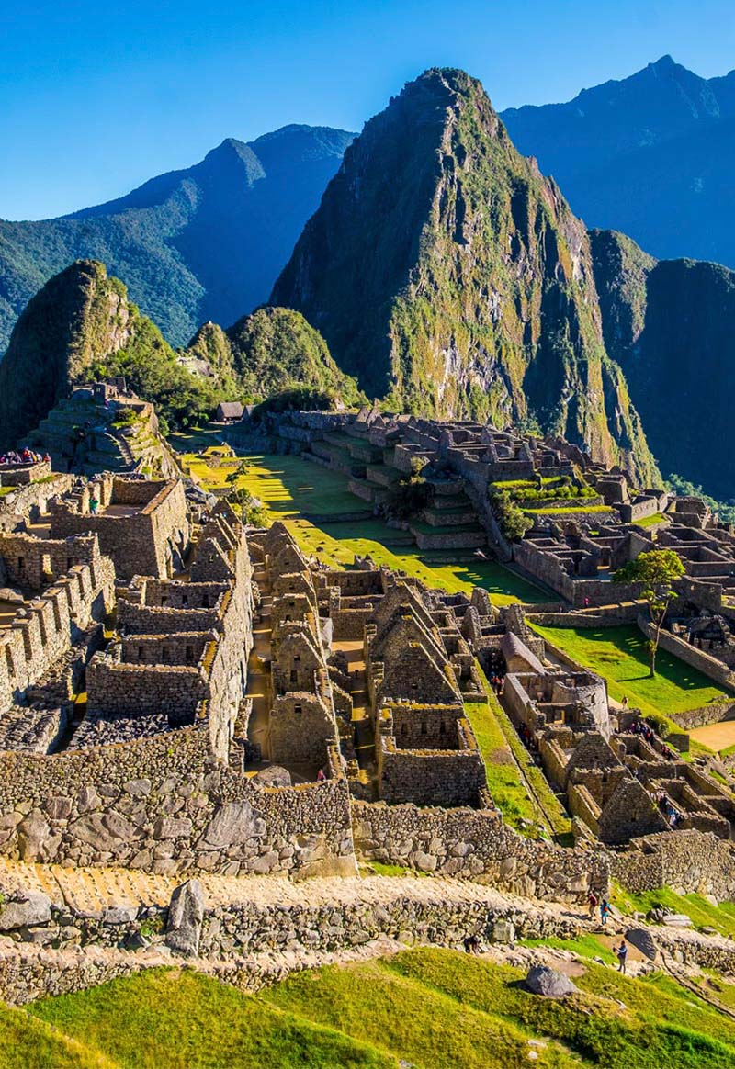

**The Inca’s Escape Game**

**Description of the game**

The origin of the Inca’s Escape Game:

The Game is an Escape Game in the Machu Picchu in Peru.

When I search for an idea, I wanted an original scenario. Indeed, I like Escape Game and enigmas.

Also, with the Covid, I need to travel and see another place than my home. I hope you too to enjoy the game and explore a beautiful sunny and historical site.

I got inspired by a French series that marked my childhood: The Mysterious Cities of Gold.

Three kids are in search of a treasure. They visit the Machu Picchu during season one.

The treasure, it’s a myth developed after the discovery of America in 1492, when the conquistadors explored the New World in search of cities teeming with riches. They claimed the existence of seven immense and rich cities never found.

The purpose of the game:

The objective of the game is to resolve many enigmas to find the Inca’s treasure in the Machu Picchu.

If the gamer wants, he can learn about the Inca civilization by asking questions to the characters in the game.

**Sketch of an initial user interface:**

When we launched the game, some initialization steps are necessary:

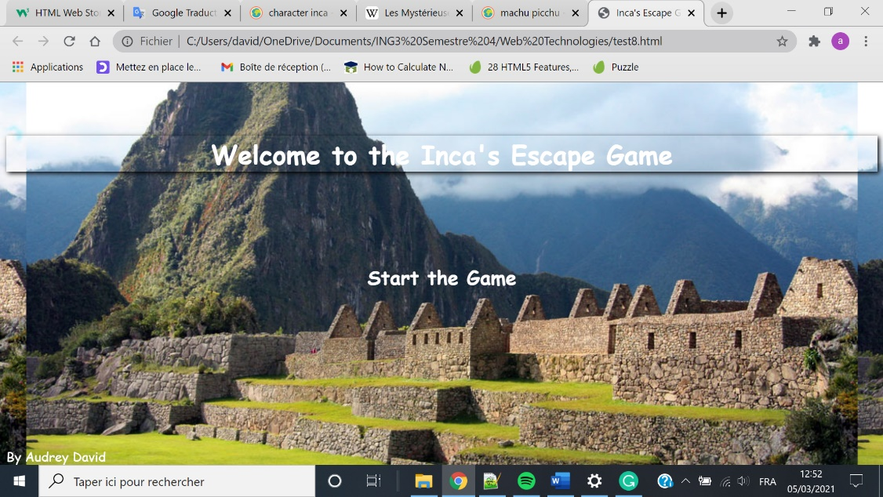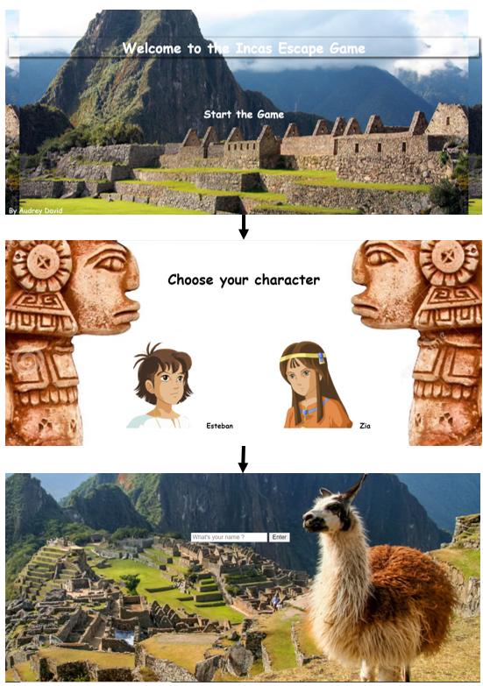

The first image is the home page. The player can start the game by clicking on the phrase "start the game".

In the second image, the player can then pick the character he wants, as we can see.

After he chooses his gender, the gamer can enter his name.

The scenario:

After this initialization phase, on the screen will appear the narration of the story. Four pages will relate the context of the game, and what mission the player must accomplish.

To change of page, he will click on the button Continue at the bottom right.

The scenario who the player will see is the next:

The principal character finished high school in Scotland.

He needs some fresh air far away from his home to be motivated to begin college. He decided to go to the end of the world: in Latin America. He can't wait to do many memories, and it's right to think that.

He takes the plane and travels to Peru. When he lands, he perceives the mood as very strange and different. He is ineffective to identify the reason concerning his anxiety. He starts his holidays and tries to forget his fear. It's the case during the first three days.

He visits the Machu Picchu. An old man approaches him, he seems uncommon, but he gives off good vibes. He catches the face of our player, which appears to recognize the aged guy.

The man puts around his neck a beautiful necklace with a gold round pendant. When it touches his skin, it shins immediately. It was almost dazzling. Something magic fills the space.

The former person is moved, smiles, and start to relate to our young adventurers:

"A long time ago, the civilization Inca was on this land. They lived in the abundance. An Inca preserved his heritage before the extinction of this civilization. He saves secrets. No one ever found the treasure. You must do all your possible to discover it and save the world. You're the one, it's your destiny."

Many questions are in his head "A treasure?", "Save the world?", "Why me?", ....

Few seconds were enough to distract him. The ancestor had magically disappeared.

Your adventure starts in the footsteps of the Incas.

**List of features**

* **A little of Inca history**

The gamer can ask questions to many characters. Indeed, these persons will tell facts about Inca civilization. It’s cool, you can learn a little of history, and if you hate that, you cannot click on the choices with questions to the characters.

* **A backpack**

During the game, many objects will be collected to resolve the enigmas. It allows the player to know what mission he has already made.

* **A local storage**

The player can stop the game and start it another day. There are many enigmas, if the player can’t resolve them, it will be better for him to try again at a different time.

If the player saves his game, he will have the possibility to click on Continue my adventure, on the home page.

* **Audio Support**

The game with background music is more fun and the immersion is better.

* **Video Support**

I imagine for the end of the game when all the solutions will be found, a video where the treasure will be open, and it will be displayed a phrase to congratulate the player.

* **Gameplay**

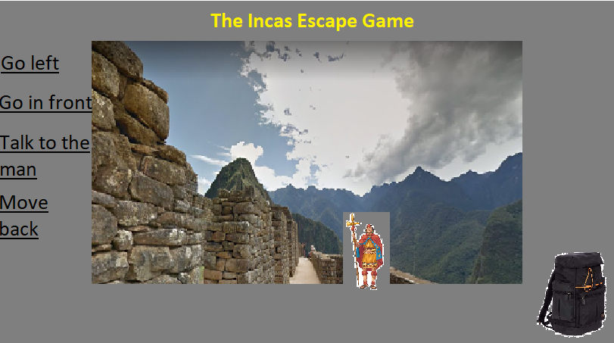The gameplay looks like the picture, with in the middle a screen capture of Google Maps to be immersed. At the right bottom, the backpack. The Inca Man to ask questions. The possibility to change of place and always move back to the site we were.

**The navigation game**

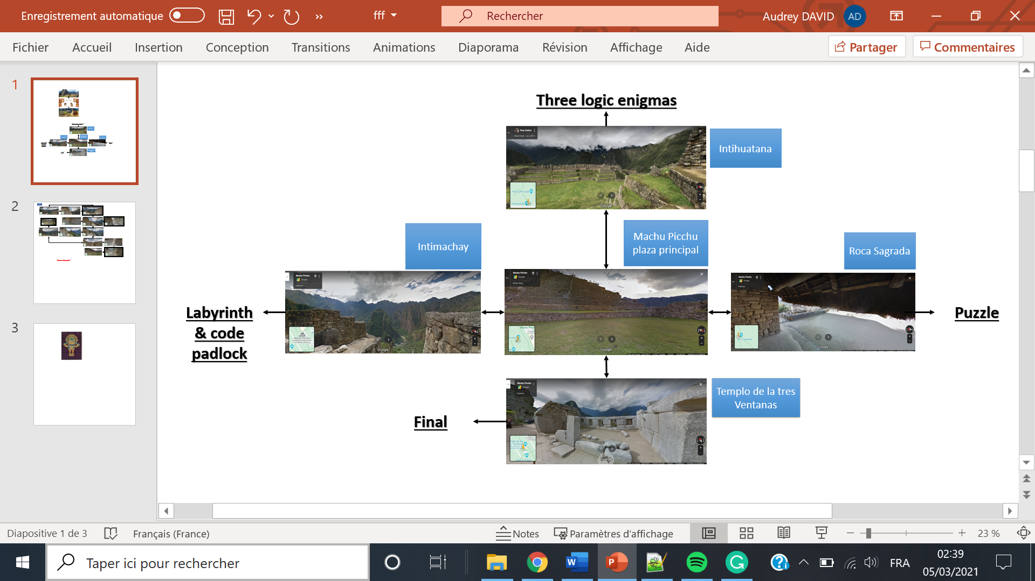

The labyrinth & code padlock:

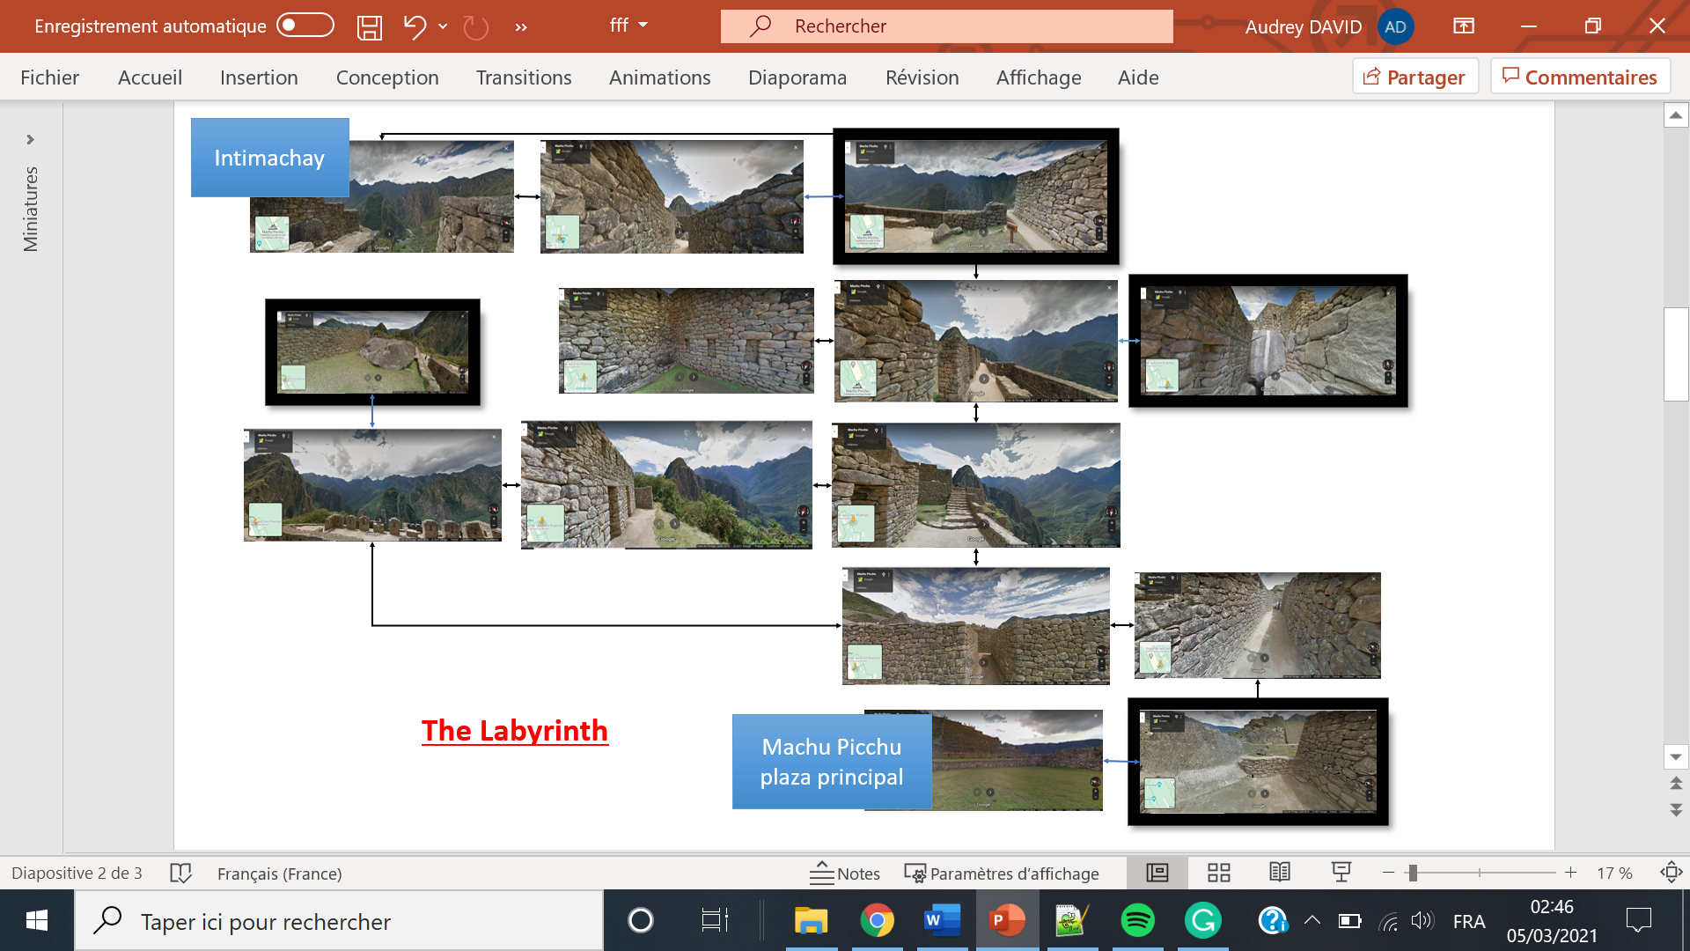The navigation tree of the labyrinth:

The purpose is to find four numbers hidden on the road.

Like we see on the image on top, four images have a black contour to represent where the player must find this number.

In croissant order, the player will enter the code.

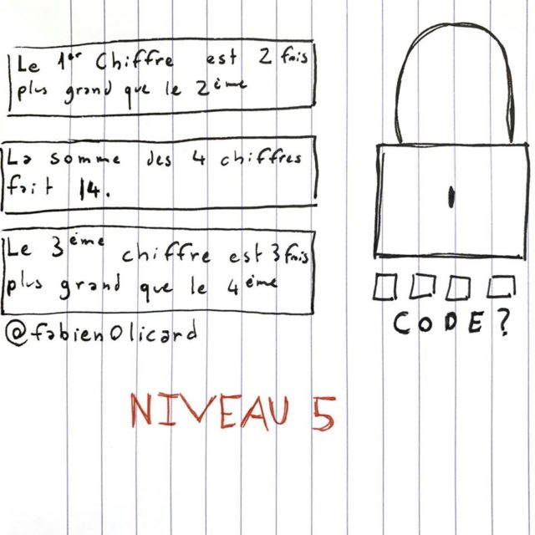

It’s an image of what the padlock will look.

The puzzle:

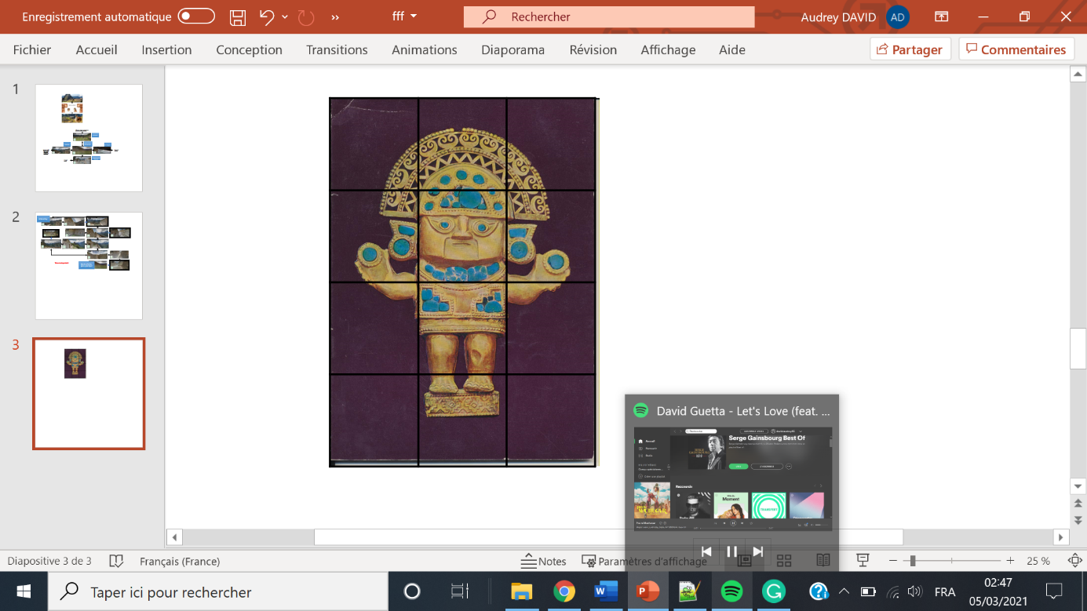

The gamer will have to find the solution to this puzzle to pass this test. Composed of 12 pieces as we can see in the picture.

The three enigmas of logic:

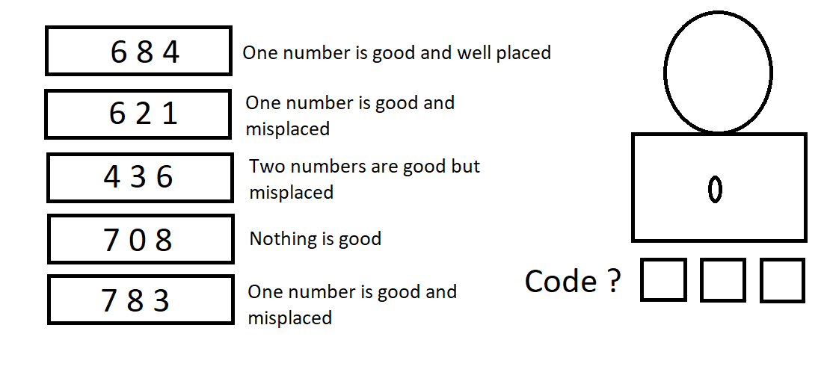The first one:

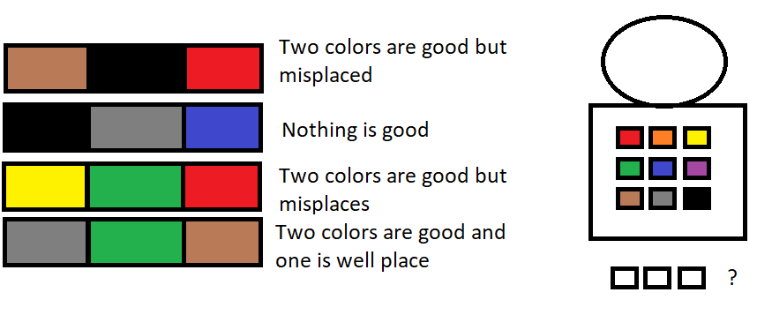The second one:

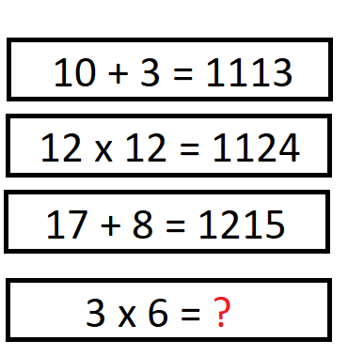The third one:

All these enigmas test the capacity of the gamer.

The Final:

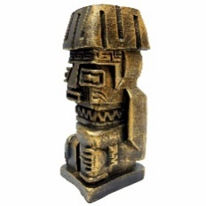

At each test passed, the player will receive a totem.

Thanks to the three totems and the necklace given by the old man.

In the final space, the player will discover the Inca’s treasure.

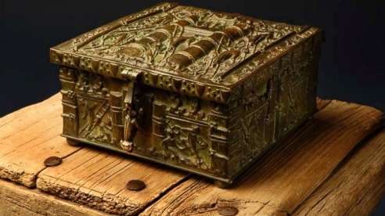

**All my research**

* **Help CSS**

<https://www.w3schools.com/howto/>

This page gives all the information when I forget something in CSS.

* **History about Inca’s civilization**

<https://www.ancient.eu/Inca_Civilization/>

This Web Site gives all the details to explain the Incas past clearly without errors.

* **Local Storage:**

<https://www.w3schools.com/html/html5_webstorage.asp>

This Web Site, with its examples, will help me to code the local storage.

* **Routes & Labyrinth**

<https://www.google.fr/maps>

Google maps will help me to have images for the background. Like we have seen in the navigation tree. I will take these pictures to immerse the player.

* **Puzzle**

<https://code.tutsplus.com/tutorials/create-an-html5-canvas-tile-swapping-puzzle--active-10747>

To code the puzzle, I found this tutorial. I think it was hard to do the realization. This Web Site indicates to me that is possible to do it.

* **Audio Support**

<https://code.tutsplus.com/tutorials/28-html5-features-tips-and-techniques-you-must-know--net-13520>

Help for the code is written on this page.

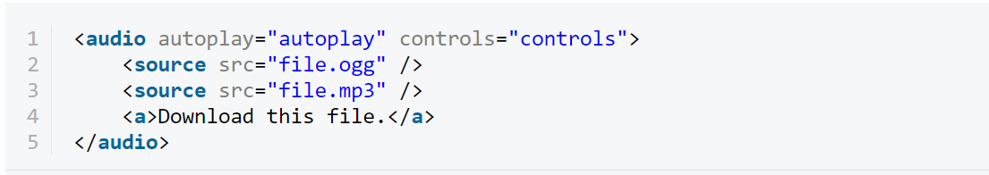

* **Video Support**

<https://code.tutsplus.com/tutorials/28-html5-features-tips-and-techniques-you-must-know--net-13520>

Same Web Site

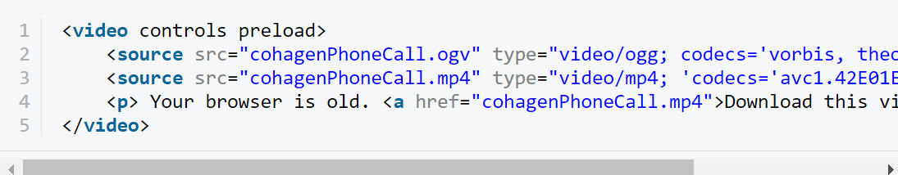

To create the video, I will use an editing software like blender a free one.

* **Collect Value**

<https://waytolearnx.com/2019/07/comment-recuperer-la-valeur-dun-input-texte-en-javascript.html>

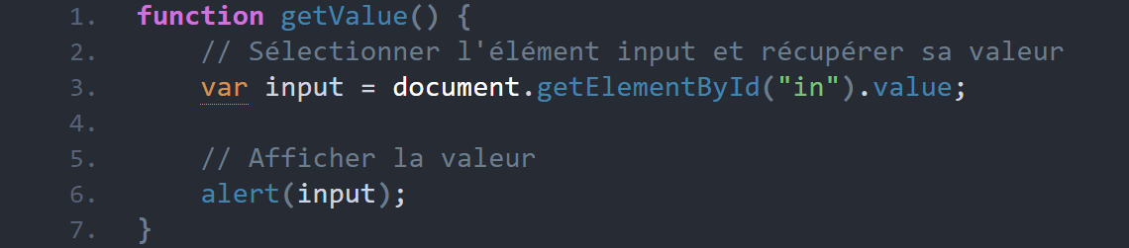

Thanks to JavaScript, we can add functions. The function on this page indicates how to collect a value. It will be helpful to solve all the enigmas.

JavaScript will also help me in the code to verify if a value is good or not. Like to check if the numbers are code to open the padlock.

* **Detect click Mouse**

<https://openclassrooms.com/fr/courses/5543061-ecrivez-du-javascript-pour-le-web/5578181-recuperez-des-donnees-utilisateur-avec-les-evenements>

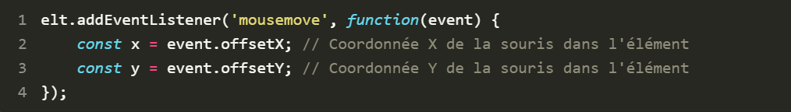

This page resumes the Utilisation of JavaScript for many events. It will be useful for the second enigmas to detect if the mouse clicks or not on a colour square, and what colour it is.

I hope you enjoy my game and are excited to play.

